Who is Tribal Raine?
Tribal Raine is Chief Finance Officer for the Paul Cuffee Abolitionist Center located in Sumter, SC. She is an Abolitionist, Book Publisher and Jewelry Designer, multi-recorded and published Spoken Word Artist whose works have been used as teaching tools for poetry college courses. Her works and videos can be found worldwide via social media, youtube.com, google, etc. She has performed on stages nationwide the nation with legends and leaders of the spoken word realm such as: NJ’s Poet Laureate - Amiri Baraka, Abiodune Oyewole of The Last Poets, Emmy & Peabody award winner and 7x HBO Def Poet – Georgia Me, HBO Def Poet -Abyss, Malcolm Jamal Warner, Nappy Roots, Queen Sheba, Black Ice, Sunny Paterson, Autumn Ashante, and more.

“I create with social awareness in mind. My work explores themes of ethnicity, poverty, equality, social taboos, diversity, racism, diaspora and a host of other social issues. The foundation for most of my creativity and muse is ‘change’. Coming from a dedication and sense of action, I believe that the words I speak and the art I create opens eyes... It questions, educates and provides a healing outlet for people to get to know themselves and society at large.”
– Tribal Raine

- 2014 Recipient of “The Lifetime Achievement Award” in Poetry along with her husband, Maximus Parthas
- Her book, Diaspora’s Children, was listed as “1 of Top 20 Books You Must Read Before You Die” by UBAWA (Urban Black Authors & Writers Alliance) – Fall 2013
- Voted # 1 in June of 2009 by OurStage.com for her single – “A Sinner’s Prayer “
- Voted Best Spoken Word CD of 2009 - “END GAME “
- Nominee for Poet of the Year 2005, 2006 & 2010 – International Library of Poetry
- Voted Featured Artists of The year 2008 - Nashville, TN, SFPC
- Headline artist for the largest Spoken Word tour in America - The NWO Word Warriors Tour 2008 & 2009
- Feature artists 4 years straight at the Sound Session Festival and Poets in Public Places located in Providence, R.I.
- Author of 11 Books
- Featured on 12 CDs, including two of her own

Affiliations:

- Member of Prysmatic Dreams since 2000
- Member of The New Word Order since 2005
- Member of Maximum Impact Poetry (with Husband/Spoken Word Artist- Maximus Parthas)
- Member of The M.O.S.E.S Project Movement since 2010

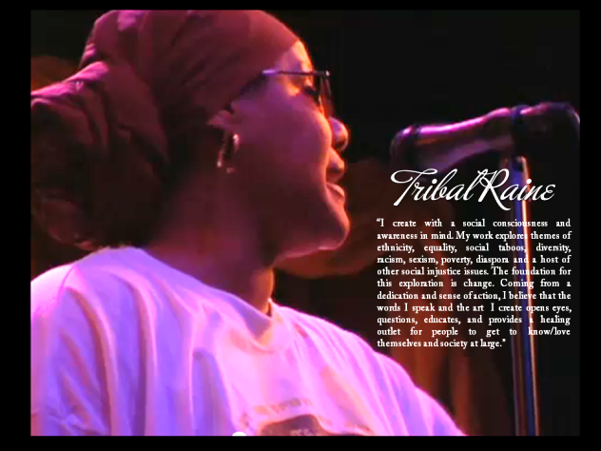

Press Kit:
http://www.ourstage.com/epk/tribalraine

Links:

www.MaximumImpactPoetry.com
www.prysmaticdreams.com
www.youtube.com/pdpresents
www.facebook.com/TribalRaine
www.prysmaticdreamspublishing.info
www.prysmaticjewels.yolasite.com

Books By Tribal Raine:

Out of The Ashes and Into The Wind
Links of Oppression
Shades of Blackness… Shades of Grace
Diaspora’s Children
In The Shadow of My Ancestors
Portraits of My People
Like A fire In My Soul
Slippery When Whet
The Love Slave Chronicles
Ink Stained Rivers
Rattle The Chains

